Q1. Which products generate the highest revenue, and what factors might explain their strong performance?

QUERY:-

SELECT ROUND(SUM(QUANTITY*UnitPrice),1) AS TOTAL_SALES,DESCRIPTION,STOCKCODE
FROM retail_clean_dedup
WHERE Description NOT IN ('POSTAGE', 'DOTCOM POSTAGE', 'Manual')
group by Description,StockCode
ORDER BY TOTAL_SALES desc
LIMIT 10;

RESULT:-

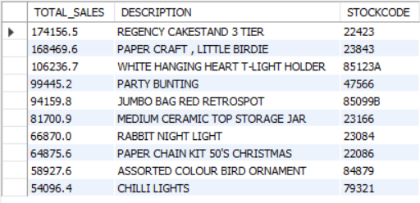

OBSERVATION:-
REGENCY CAKESTAND 3 TIER and PAPER CRAFT, LITTLE BIRDIE are the two highest revenue-generating products, generating approximately £174.2K and £168.5K respectively. Both products contribute significantly more revenue than the remaining products in the top 10, making them the primary revenue drivers for the business.

BUSINESS INSIGHTS:-
The strong revenue performance of REGENCY CAKESTAND 3 TIER and PAPER CRAFT, LITTLE BIRDIE suggests that these products are key revenue drivers for the business. Their success may be influenced by factors such as high customer demand, higher selling prices, repeat purchases, or strong product visibility. While the current dataset confirms their revenue contribution, additional analysis of purchase frequency and pricing would be required to determine the exact drivers of their performance.

RECOMMENDATION
The business should maintain adequate inventory for these products, closely monitor their sales performance, and prioritize them in marketing campaigns. At the same time, management should further analyze whether their success is driven by high demand, premium pricing, or repeat purchases so that similar strategies can be applied to other products.

Q2. Which countries contribute the highest revenue, and which countries demonstrate strong purchasing activity despite lower revenue, indicating future growth opportunities?

QUERY:- REVENUE ANALYSIS

SELECT
Country,
ROUND(SUM(Revenue),2) AS Total_Revenue
FROM retail_clean_dedup
GROUP BY Country
ORDER BY Total_Revenue DESC
LIMIT 10;

RESULT:-
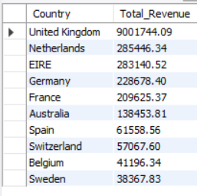

Observation:
The United Kingdom is the primary revenue driver, generating approximately £900.2K, far exceeding all other countries. The Netherlands and EIRE are the next highest revenue contributors, followed by Germany and France.

Business Insight:
The business relies heavily on the United Kingdom for revenue generation. This indicates a strong market presence in the UK but also suggests a dependency on a single market. Any decline in demand or market conditions in the UK could significantly impact the company's overall revenue.

QUERY 2:- PURCHASING ACTIVITY BY COUNTRY

SELECT
Country,
COUNT(DISTINCT InvoiceNo) AS Total_Orders,
ROUND(SUM(Revenue),2) AS Total_Revenue
FROM retail_clean_dedup
GROUP BY Country
ORDER BY Total_Orders DESC
LIMIT 10;

RESULT:-
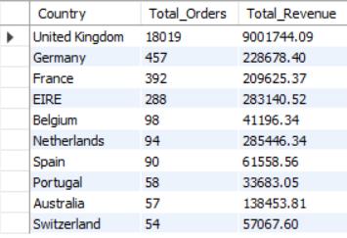

Observation:
The United Kingdom is the dominant market, generating the highest revenue (£900.2K) along with the highest number of orders (18,019), indicating strong customer demand and purchasing activity. Germany and France also show high purchasing activity through a large number of orders, while the Netherlands generates one of the highest revenues despite having only 94 orders.

Business Insight:
The Netherlands demonstrates a significantly higher revenue per order compared to Germany and France. This suggests that customers in the Netherlands tend to place higher-value orders, whereas Germany and France generate revenue through a larger number of smaller purchases. These markets may therefore require different business strategies to maximize revenue.

Final Recommendation:
The business should continue prioritizing the United Kingdom, as it is the strongest revenue-generating market with the highest purchasing activity. The Netherlands should be targeted with premium product offerings and customer retention strategies, as customers in this market generate high revenue despite placing fewer orders. In Germany and France, the company should focus on increasing the average order value through upselling, cross-selling, and promotional bundles, allowing the business to convert strong purchasing activity into higher revenue while reducing dependence on a single market.

Q3. Who are the highest-value customers, and what percentage of total revenue is contributed by the top customers?

QUERY 1 :- Who are the highest-value customers?

SELECT
CustomerID,
ROUND(SUM(Revenue),2) AS Total_Revenue,
COUNT(DISTINCT InvoiceNo) AS Total_Orders
FROM retail_clean_dedup
WHERE CustomerID IS NOT NULL
GROUP BY CustomerID
ORDER BY Total_Revenue DESC
LIMIT 10;

RESULT:-
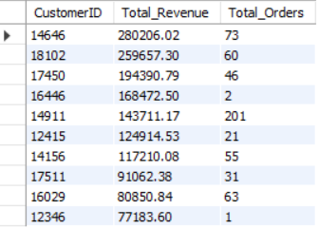

Observation:
- Customer 14646 generated the highest revenue (280,206.02) with 73 orders, indicating both high purchase frequency and high overall customer value.
- Customers 18102 and 17450 also contributed significant revenue, showing that the business has multiple consistently high-value customers rather than relying on only one customer.
- Customer 16446 generated 168,472.50 from only 2 orders, indicating an exceptionally high average order value. This customer represents a premium or bulk buyer.
- Customer 12346 generated 77,183.60 from just 1 order, suggesting a one-time large purchase rather than frequent buying behavior.
- The top customers display different purchasing patterns—some generate revenue through frequent repeat purchases, while others contribute through few but very high-value transactions.

Business Insight:
The analysis indicates two distinct types of VIP customers:
- Customer 14646 is a high-frequency, high-value customer. The business should focus on retaining and growing this customer through personalized offers, loyalty rewards, exclusive discounts, and cross-selling/upselling opportunities to increase lifetime value.
- Customers 16446 and 12346 represent premium/bulk buyers, generating exceptionally high revenue from very few orders. These customers should receive dedicated relationship management, priority service, and customized pricing or contract-based offers to encourage repeat large-value purchases.

QUERY2 :- Revenue Contribution of Top Customers

WITH CustomerRevenue AS (
SELECT
CustomerID,
SUM(Revenue) AS Total_Revenue
FROM retail_clean_dedup
WHERE CustomerID IS NOT NULL
GROUP BY CustomerID
),

Top10Customers AS (
SELECT *
FROM CustomerRevenue
ORDER BY Total_Revenue DESC
LIMIT 10
),

TotalCompanyRevenue AS (
SELECT SUM(Revenue) AS Company_Revenue
FROM retail_clean_dedup
)

SELECT
ROUND(
(SUM(t.Total_Revenue) / MAX(c.Company_Revenue)) * 100,
2
) AS Percentage_Contribution
FROM Top10Customers t
CROSS JOIN TotalCompanyRevenue c;

RESULT :-

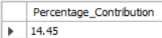

Observation

- The top 10 customers contribute only 14.45% of the company's total revenue.
- Revenue is distributed across a broad customer base rather than being concentrated among a few customers.
- The business is not heavily dependent on a small group of VIP customers for generating sales.

Business Insight

- The company has a well-diversified customer base, reducing the financial risk associated with losing a few high-value customers.
- Although the top customers are valuable, long-term growth depends on maintaining a large and active customer base rather than relying on only a handful of VIP customers.
- The business should continue rewarding high-value customers while also investing in customer acquisition and retention strategies for the wider customer base to sustain stable revenue growth.
Final Recommendation:
- The company should implement personalized loyalty programs, exclusive offers, and upselling strategies for high-value customers such as 14646, 16446, and 12346 to maximize customer lifetime value and encourage repeat purchases. However, since the top 10 customers contribute only 14.45% of total revenue, the business already benefits from a well-diversified customer base. Therefore, alongside retaining VIP customers, the company should continue investing in customer acquisition, retention, and engagement programs for the broader customer base to maintain stable long-term revenue growth while minimizing customer concentration risk.

Q4. Which products have the highest sales volume, and are they also the highest revenue-generating products?

QUERY :-
SELECT DESCRIPTION,ROUND(SUM(REVENUE),1) AS TOTAL_REVENUE,SUM(QUANTITY) AS TOTAL_QUANTITY,
RANK()OVER(ORDER BY SUM(Quantity)DESC) AS QUANTITY_RANK,
RANK ()OVER(ORDER BY ROUND(SUM(REVENUE),1) DESC) AS REVENUE_RANK
FROM retail_clean_dedup
GROUP BY DESCRIPTION
ORDER BY TOTAL_QUANTITY desc
LIMIT 10;

RESULT:-
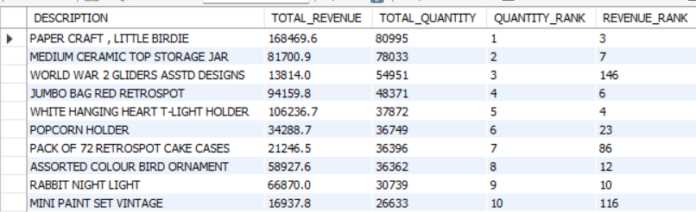

Observation
- PAPER CRAFT, LITTLE BIRDIE is the highest-demand product, selling 80,995 units, and also ranks among the top revenue-generating products (Revenue Rank #3).
- However, high demand does not always translate into high revenue. For example, WORLD WAR 2 GLIDERS ASSTD DESIGNS ranks 3rd in quantity sold but only 146th in revenue, indicating that it is a high-volume, low-revenue product.
- Some products, such as WHITE HANGING HEART T-LIGHT HOLDER, maintain both high demand and high revenue, demonstrating a balanced product performance.

Business Insight
The business benefits from a healthy mix of products that generate both strong demand and strong revenue. However, several high-demand products contribute relatively less revenue, suggesting that product pricing, product mix, or sales strategy may be limiting their revenue potential.

Recommendation
- Prioritize inventory availability for products that consistently achieve both high demand and high revenue, such as PAPER CRAFT, LITTLE BIRDIE and WHITE HANGING HEART T-LIGHT HOLDER, to minimize stock-outs.
- Review pricing, bundling, and cross-selling opportunities for products with high demand but comparatively low revenue to improve profitability without reducing sales volume.
- Continue monitoring the balance between product demand and revenue to optimize both inventory investment and marketing strategy.

Q5. How do monthly sales trends change over time, and which months represent peak business opportunities?

QUERY :-
WITH cte1 AS
(
SELECT
YEAR(InvoiceDate) AS Year1,
MONTH(InvoiceDate) AS Month1,
ROUND(SUM(Revenue),2) AS Revenue
FROM retail_clean_dedup
GROUP BY YEAR(InvoiceDate), MONTH(InvoiceDate)
)

SELECT
Year1,
Month1,
Revenue,
LAG(Revenue) OVER(ORDER BY Year1, Month1) AS Previous_Month_Revenue,
Revenue - LAG(Revenue) OVER(ORDER BY Year1, Month1) AS Revenue_Difference
FROM cte1
ORDER BY Year1, Month1;

RESULT :-

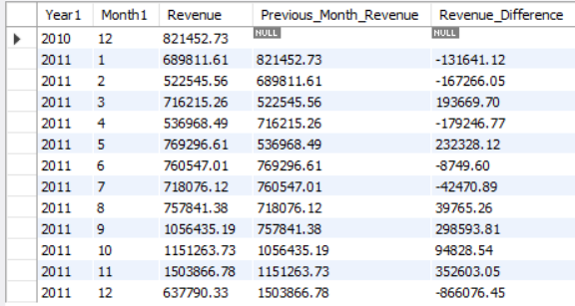

Observation

- Monthly sales showed significant fluctuations throughout the analysis period rather than a consistent upward trend.
- Revenue increased sharply from September to November 2011, indicating a strong seasonal sales period.
- November 2011 recorded the highest monthly revenue (≈ 1.50 Million), making it the peak sales month.
- A substantial decline in revenue was observed in December 2011 compared to November, suggesting the need for further investigation.

Business Insight
- Customer demand appears to strengthen during the final quarter of the year, especially between September and November.
- These months represent the most valuable sales opportunities and have the greatest impact on overall annual revenue.
- The sharp decline after November may be caused by seasonality, operational constraints, or incomplete reporting, requiring additional business investigation.

Recommendation

- Increase inventory levels before the high-demand season, preferably beginning in August or early September.
- Launch seasonal marketing campaigns ahead of the peak sales period to maximize revenue.
- Investigate the reasons behind the significant revenue decline in December to identify potential operational or market-related issues.
- Use historical monthly sales trends to improve future demand forecasting and inventory planning.

Q6. Which products emerge as the top-selling products in each month, indicating potential seasonal demand patterns?

QUERY :-
WITH cte AS (
SELECT
Description,
MONTH(InvoiceDate) AS month_no,
MONTHNAME(InvoiceDate) AS month,
SUM(Quantity) AS units_sold,
ROUND(SUM(Revenue), 2) AS total_revenue,
ROW_NUMBER() OVER (
PARTITION BY MONTH(InvoiceDate)
ORDER BY SUM(Quantity) DESC
) AS rn
FROM retail_clean_dedup
GROUP BY Description, MONTH(InvoiceDate), MONTHNAME(InvoiceDate)
)

SELECT
Description,
month,
units_sold,
total_revenue
FROM cte
WHERE rn = 1
ORDER BY month_no;

RESULT : -

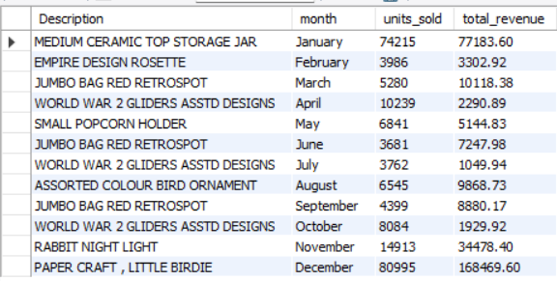

Observations
1. JUMBO BAG RED RETROSPOT emerged as the most consistent top-performing product, ranking as the highest-selling product in three different months (March, June, and September). This indicates stable customer demand and strong market acceptance throughout the year.
2. WORLD WAR 2 GLIDERS ASSTD DESIGNS also demonstrated recurring demand by becoming the monthly best-selling product in April, July, and October, highlighting its sustained popularity during multiple periods of the year.
3. PAPER CRAFT, LITTLE BIRDIE recorded the highest monthly revenue (£168,469.60) and the highest sales volume (80,995 units) in December, significantly outperforming all other monthly top-selling products. This suggests an exceptional year-end demand surge, likely driven by seasonal purchasing behavior.
4. The monthly best-selling product changed across the year, indicating that customer purchasing preferences vary over time rather than being dominated by a single product category. This highlights the importance of adopting month-specific inventory and promotional strategies.

Business Impact

Monthly top-selling products contribute significantly to monthly revenue. If these products are not adequately stocked and managed, the business may experience stockouts, lost sales opportunities, and a decline in monthly revenue. Therefore, businesses should prioritize inventory planning and promotional strategies for products expected to perform strongly in each month.

Business Recommendations
- Ensure that the expected top-selling products are stocked before the start of each month, preferably during the last few days of the previous month. This helps avoid stock shortages and ensures that customer demand can be fulfilled without affecting monthly revenue.
- Pay special attention to products that repeatedly become monthly best sellers, such as JUMBO BAG RED RETROSPOT and WORLD WAR 2 GLIDERS ASSTD DESIGNS. Their recurring demand patterns can be used to plan inventory, purchasing, and promotions more effectively.
- For products that show exceptional seasonal demand, like PAPER CRAFT, LITTLE BIRDIE in December, increase inventory and promotional efforts in advance to maximize sales during peak demand periods.

Q7. Customer Purchase Behaviour Analysis Which customers place frequent low-value orders, and which customers place fewer but high-value orders?
PART 1 :- Frequent Low-Value Customers

QUERY:-
WITH CTE AS(
SELECT CustomerID,COUNT( DISTINCT InvoiceNo) AS TOTAL_ORDERS,ROUND(SUM(Revenue),0) AS TOTAL_REVENUE
FROM retail_clean_dedup
WHERE CustomerID IS NOT NULL
GROUP BY CustomerID)
select*,ROUND((TOTAL_REVENUE/TOTAL_ORDERS),0) AS AVG_ORDER_VALUE
FROM CTE
order by total_orders desc
limit 20;

RESULT :-
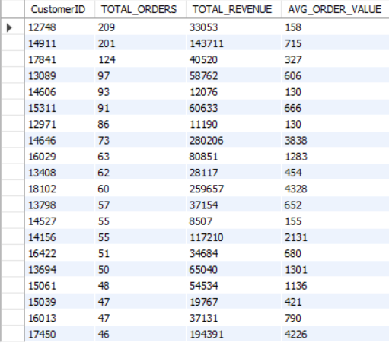
Observation
- Customer 12748 placed the highest number of orders (209) but has a low AOV (158.1), indicating frequent small purchases.
- Similar behaviour is observed for customers such as 17841, 14606, and 12971.
- High purchase frequency does not necessarily translate into high customer value.

Business Insight
- The business already has a loyal customer segment that purchases frequently. Increasing the average basket size of these customers could generate additional revenue without relying solely on new customer acquisition.

Recommendation
- Implement upselling, cross-selling, product bundles, and minimum order value promotions to increase the Average Order Value of frequent customers while maintaining their loyalty.

PART 2 :- Which customers place fewer but high-value orders?

QUERY :-

WITH CTE AS(
SELECT CustomerID,COUNT( DISTINCT InvoiceNo) AS TOTAL_ORDERS,ROUND(SUM(Revenue),0) AS TOTAL_REVENUE
FROM retail_clean_dedup
WHERE CustomerID IS NOT NULL
GROUP BY CustomerID
)
select*,ROUND((TOTAL_REVENUE/TOTAL_ORDERS),0) AS AVG_ORDER_VALUE
FROM CTE
order by AVG_ORDER_VALUE desc
limit 20;

RESULT:-
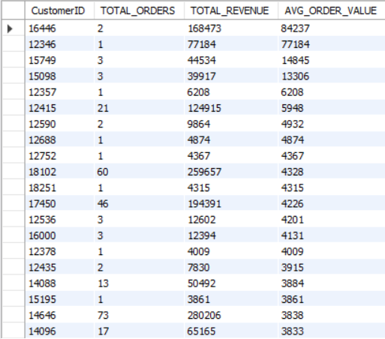

Observation
Customer 16446, despite placing only 2 orders, achieved the highest Average Order Value (AOV), indicating a preference for high-value purchases. Similarly, Customer 12346 generated approximately 77K revenue from a single order, while customers 15749 and 15098 also generated high revenue with relatively few orders. This indicates that some customers contribute significantly through large-value transactions rather than frequent purchases.

Business Insight
The analysis identifies a segment of high-value customers who generate substantial revenue through a small number of premium purchases. Retaining these customers is critical, as losing even a few of them could have a noticeable impact on overall revenue.

Recommendation
Implement VIP loyalty programs, personalized offers, dedicated customer support, and exclusive access to premium products for these high-value customers. The primary objective should be to retain these customers and strengthen long-term relationships, as they contribute significantly despite placing fewer orders.

Q8. Is business revenue diversified across products and customers, or is it heavily dependent on a small number of products or customers?

QUERY :- IS IT DEPENDENT ON ANY PARTICULAR PRODUCT?

WITH cte AS (
SELECT
Description,
ROUND(SUM(Revenue), 2) AS revenue_by_product
FROM retail_clean_dedup
GROUP BY Description
),

cte2 AS (
SELECT
SUM(Revenue) AS total_revenue
FROM retail_clean_dedup
)

SELECT
cte.Description,
cte.revenue_by_product,
ROUND((cte.revenue_by_product * 100.0) / cte2.total_revenue, 2) AS contribution_percent
FROM cte
CROSS JOIN cte2
ORDER BY contribution_percent DESC
limit 10;

RESULT:-

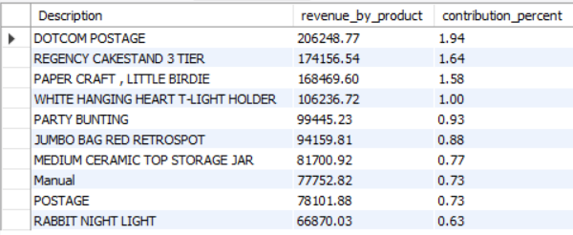

Observation
- The top 10 revenue-generating products collectively contribute only around 10–11% of total revenue.
- The highest revenue-generating product (DOTCOM POSTAGE) contributes only 1.94% of total revenue.
- No single product contributes a dominant share of business revenue, indicating that sales are distributed across a wide range of products.

Business Insight
The business has a highly diversified product portfolio. Revenue is generated collectively by a large number of products rather than relying on a few best-selling items. This reduces product concentration risk and makes the business more resilient, as the discontinuation or poor performance of any single product is unlikely to have a significant impact on overall revenue.

QUERY 2 :- IS IT DEPENDENT ON FEW CUSTOMERS ?

WITH customer_revenue AS (
SELECT
CustomerID,
SUM(Revenue) AS revenue_by_customer
FROM retail_clean_dedup
WHERE CustomerID IS NOT NULL
GROUP BY CustomerID
),

total_revenue AS (
SELECT SUM(Revenue) AS total_revenue
FROM retail_clean_dedup
)

SELECT
cr.CustomerID,
ROUND(cr.revenue_by_customer, 2) AS revenue_by_customer,
ROUND(
(cr.revenue_by_customer / tr.total_revenue) * 100,
2
) AS contribution_percent
FROM customer_revenue cr
CROSS JOIN total_revenue tr
ORDER BY revenue_by_customer DESC
LIMIT 10;

RESULT :-

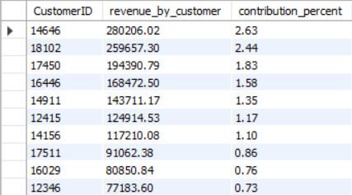

Final Business Recommendation
The business should continue maintaining its diversified product portfolio and broad customer base, as both significantly reduce revenue concentration risk and improve long-term business stability. While no single product or customer contributes a dominant share of total revenue, the company should continue investing in high-performing products, strengthen relationships with high-value customers, and regularly monitor revenue concentration trends. This balanced strategy can support sustainable growth while minimizing the financial risk associated with the loss of any individual product or customer.

Q9. Which customers have not made purchases recently and may be at risk of churning?

QUERY :-
WITH customer_retention AS (
SELECT
CustomerID,
SUM(Revenue) AS Total_Revenue,
MAX(InvoiceDate) AS Last_Purchase_Date,
DATEDIFF(
(SELECT MAX(InvoiceDate) FROM retail_clean_dedup),
MAX(InvoiceDate)
) AS Days_Since_Last_Purchase
FROM retail_clean_dedup
WHERE CustomerID IS NOT NULL
GROUP BY CustomerID
)

SELECT
CASE
WHEN Days_Since_Last_Purchase <= 30 THEN 'Active'
WHEN Days_Since_Last_Purchase <= 90 THEN 'At Risk'
ELSE 'Inactive'
END AS Customer_Status,

COUNT(*) AS Total_Customers,

ROUND(COUNT(*) * 100.0 /
(SELECT COUNT(*) FROM customer_retention),2) AS Customer_Percentage,

ROUND(SUM(Total_Revenue),2) AS Revenue,

ROUND(SUM(Total_Revenue) * 100.0 /
(SELECT SUM(Total_Revenue) FROM customer_retention),2) AS Revenue_Percentage

FROM customer_retention
GROUP BY Customer_Status;

RESULT:-

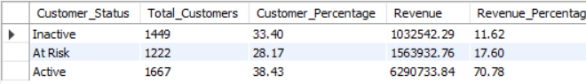

Observation
- Customers are fairly distributed across all three segments:
  - Active: 38.43%
  - At Risk: 28.17%
  - Inactive: 33.40%
- However, revenue is not distributed equally.
- Although Active customers represent only 38.43% of the customer base, they contribute 70.78% of the total revenue.
- This indicates that the business relies heavily on its active customers for revenue generation.
- On the other hand, At Risk and Inactive customers together account for over 61% of customers but contribute only 29.22% of total revenue.

Business Insight
The business is currently in a healthy position because its active customers generate the majority of revenue. However, the company faces customer concentration risk, as a relatively small portion of customers contributes most of the revenue. Losing high-value active customers could significantly impact overall sales and profitability.

Recommendation
- Prioritize retaining At Risk customers through personalized emails, loyalty rewards, and targeted promotional offers before they become inactive.
- Strengthen retention of Active customers by introducing VIP programs, exclusive benefits, and personalized engagement strategies to maintain long-term loyalty.
- Launch re-engagement campaigns for Inactive customers using win-back offers or discounts, while simultaneously analyzing the reasons for customer churn and addressing the underlying issues.

Final Consultant Recommendation
Based on the overall analysis, the business demonstrates a strong and diversified revenue model supported by a broad customer base and a wide product portfolio. Revenue is not heavily dependent on a single product or customer, reducing overall concentration risk. However, significant opportunities exist to improve long-term growth by strengthening customer retention, increasing average order value, and optimizing inventory based on seasonal demand patterns. The company should continue investing in its highest-performing products and markets while implementing targeted retention strategies for active and at-risk customers. Additionally, leveraging customer segmentation, personalized marketing, and demand forecasting will help improve revenue stability, customer lifetime value, and sustainable business growth.

